CUPCAKE RECIPE

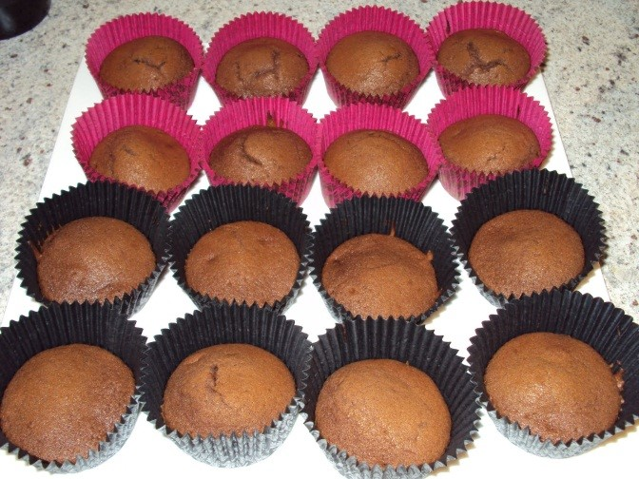
INGREDIENTS:
125g butter softened
1 tsp vanilla essence
½ cup caster sugar
2 eggs
1 cup plain flour
2 tsp baking powder
¼ cup milk

TO START:
1) Get all your equipment and ingredients ready
2) Preheat the oven to bake at 190° C
3) Place patty cases in muffin trays

METHOD:
- Cream the butter, vanilla essence and sugar until light and fluffy
- Add eggs one at a time, beating well after each addition
- Sift the flour and baking powder together
- Fold into the creamed mixture
- Stir in the milk
- Spoon mixture evenly into patty cases
- Bake for 15 minutes or until cakes spring back when lightly touched
CHOCOLATE CUPCAKES:
Leave out 2 Tbsp of flour and replace with 2 Tbsp of cocoa

